Abbreviated Brand Guidelines

You must agree to the Padgett logo guidelines in order to use the Padgett logo.

Our logo
Our logo is the cornerstone of our visual identity. The Padgett logo is the most visible representation of our brand and the unifying visual element that appears across all communications and channels. It serves as a powerful reminder of our commitment and partnership with our clients for growth and long-term success.

Our logo has two equally important components—the diamond symbol and the word-mark. They must stay intact and never be used separately.

Our primary logo is available in a full-color, vertical or horizontal configuration. The primary logo should appear on white or light gray wherever possible. The reverse version is considered our secondary logo. It should only be used against our main brand color—dark navy blue—or when used against dark, photographic backgrounds.

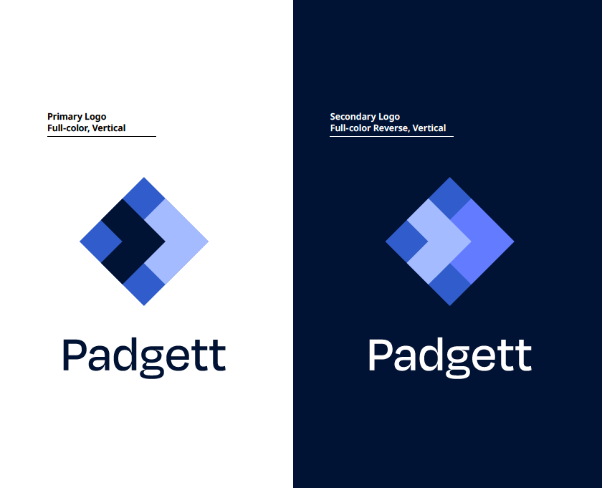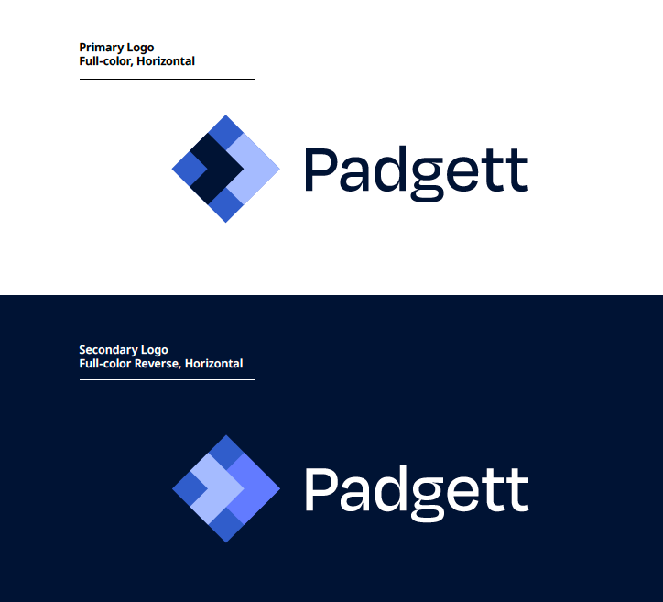

Do not change the scale or proportion of any part of the logo, apply special effects (ie: drop shadow), place the logo against busy backgrounds or stretch or distort the logo.

Clear space
Clear space is the minimum “breathing room” maintained around our logo. It is kept free of graphics, text, and other marks. It also defines the minimum distance between the logo and the edge of a printed piece. Always consider clear space rules in communications when choosing the stacked or vertical version.

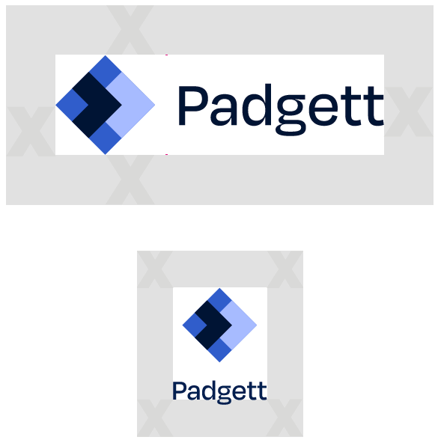

Minimum sizes
Minimum size refers to the smallest allowable logo where our logo is still legible and identifiable.

Horizontal: 1.625 inches / 117 px wide (always adjust logos proportionately when sizing)
Vertical: 0.625 inches / 46 px wide (always adjust logos proportionately when sizing)

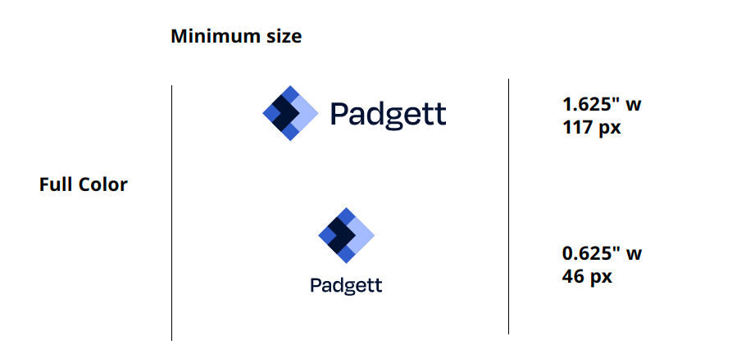
Color
Our color palette is modern, credible and uplifting. Padgett Navy Represents the professionalism and stability that Padgett offers its clients Padgett Navy should be emphasized in all communications either as a background or type color. Our complementary blues are Cobalt, Flint and Cornflower. Navy, Flint and Cornflower should be emphasized over Cobalt. We also use white to bring a clean, modern sensibility to our look and enhances the presentation of our logo.

 |  | Padgett Navy | Pantone 281  CMYK  C=100 M=83 Y=0 K=74 | RGB  R=0 G=20 B=60  HEX  #00143c
 |  | Flint | Pantone 2128  CMYK  C=39 M=19 Y=0 K=0 | RGB  R=176 G=195 B=255  HEX  #b0c3ff
 |  | Cornflower | Pantone 7452  CMYK  C=52 M=37 Y=0 K=0 | RGB  R=110 G=136 B=255  HEX  #6e88ff
 |  | Cobalt | Pantone 2131  CMYK  C=87 M=66 Y=0 K=0 | RGB  R=55 G=104 B=209  HEX  #3768d1
 |  | White | CMYK  C=0 M=0 Y=0 K=0 | RGB  R=255 G=255 B=255  HEX  #FFFFFF

